**GIT Branching**

**Objective:** Commit HTML, CSS & JavaScript assignments into GIT.

**Section-1: (HTML assignments)**

1. First take a backup of your assignments & projects. This is required because due to incorrect GIT operation you may lose your files.

2. Create an empty directory ‘Assignments’ & cd to ‘Assignments’.

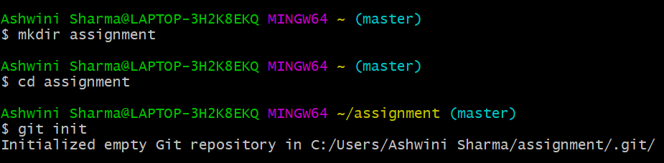

3. Create a file README.txt inside ‘Assignments’ & write few lines about the contents of ‘Assignments’ folder.

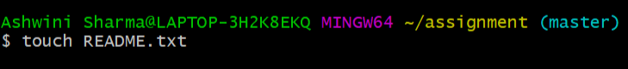

4. Commit README.txt file.

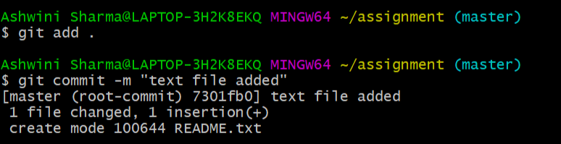

5. Now create a new branch ‘html-assignments’.

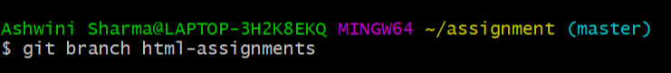

6. Switch to ‘html-assignments’ branch.

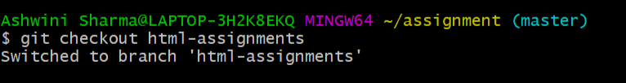

7. Copy all HTML assignments inside ‘Assignments’ folder.

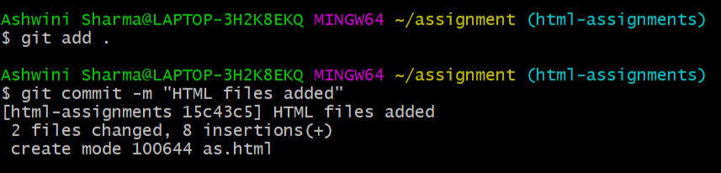

8. Commit HTML assignments into ‘html-assignments’ branch.



9. Make minor changes into few files belonging to ‘html-assignments’ branch.

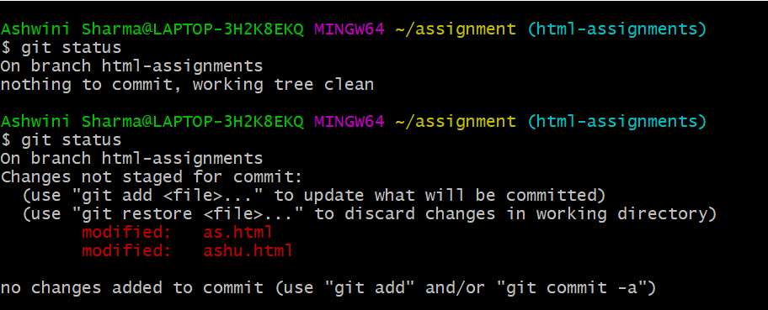

10. Commit those changed files.

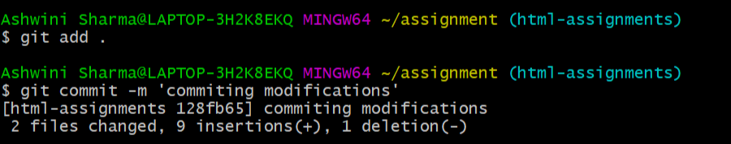

11. Switch to master branch.

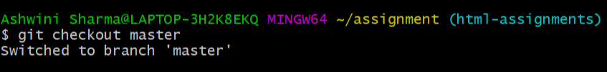

12. Make minor changes into README.txt file & commit those changes into master.

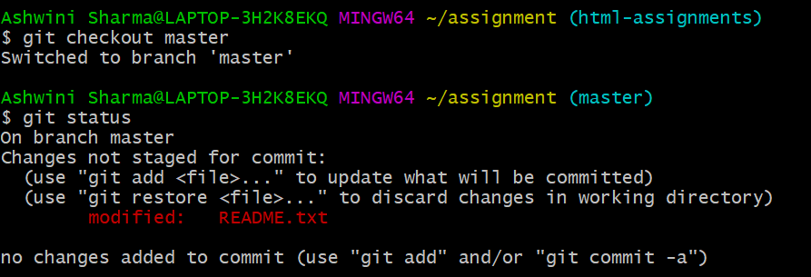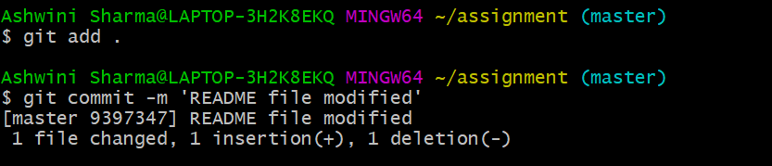

13. Again switch to ‘html-assignments’ branch.

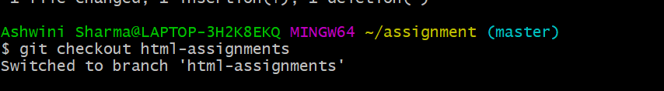

14. Make minor changes into few files belonging to ‘html-assignments’ branch.

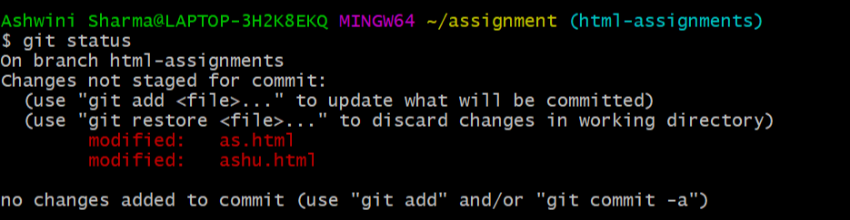

15. Commit those changes.

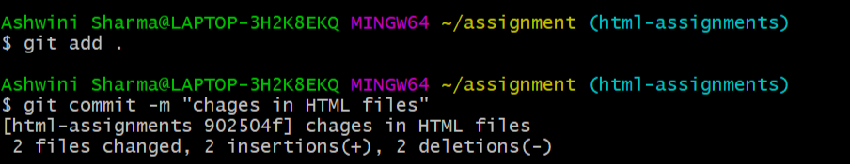

16. Switch to master.

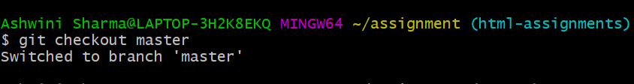

17. Merge ‘html-assignments’ branch into master. Confirm all html assignments are shown in master.

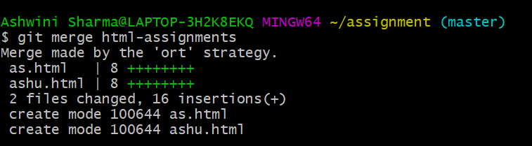

18. Finally delete the ‘html-assignments’ branch.

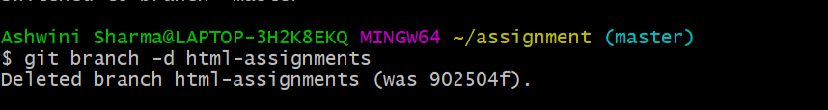

**SECTION-2 - (CSS assignments) Steps to follow:**

1. Create a new branch ‘css-assignments’.

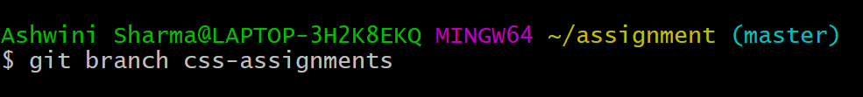

1. Switch to ‘css-assignments’ branch.

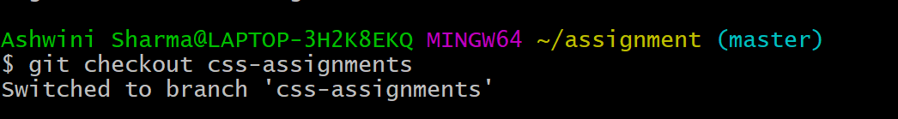

1. Copy all CSS assignments inside ‘Assignments’ folder.

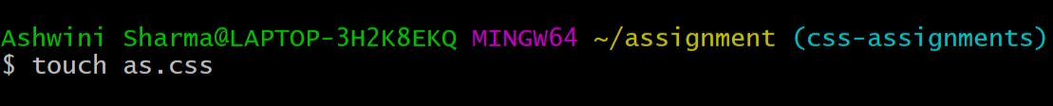

1. Commit CSS assignments into ‘css-assignments’ branch.

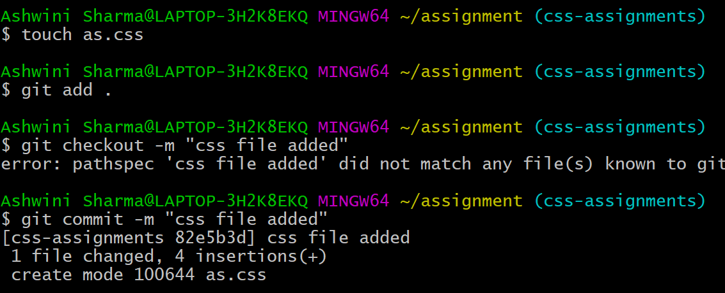

1. Make minor changes into README.txt file on line 1 belonging to ‘css-assignments’ branch.

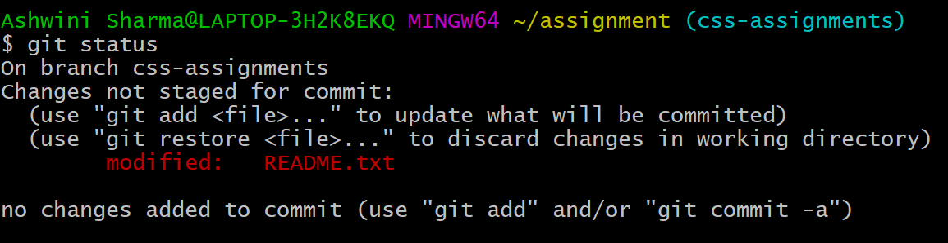

1. Commit those changed files.

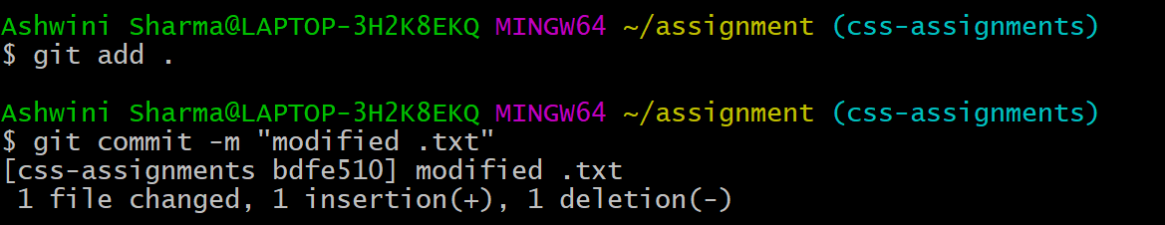

1. Switch to master branch.

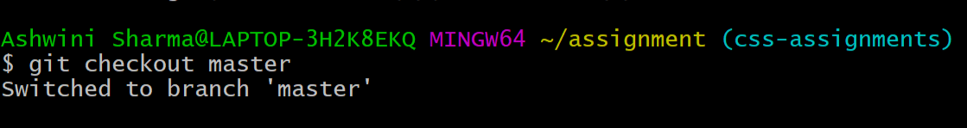

1. Make minor changes into README.txt file on line 3 & commit those changes into master.

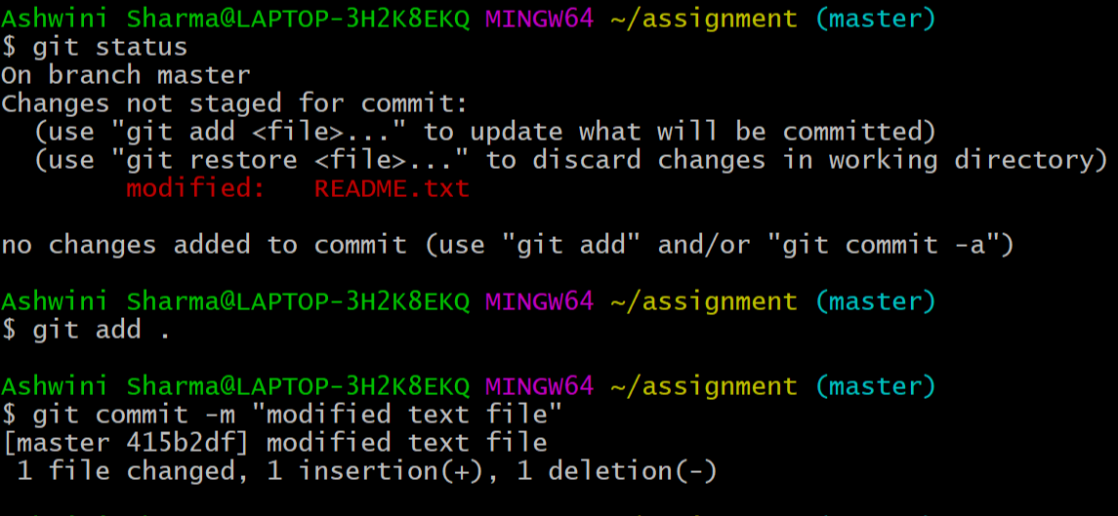

1. Again switch to ‘css-assignments’ branch.

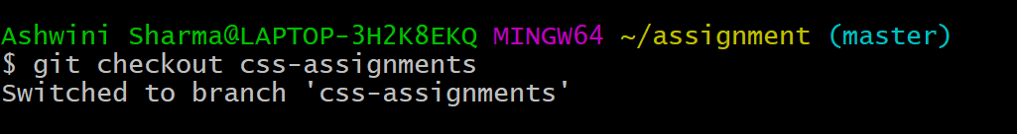

1. Make minor changes into few files belonging to ‘css-assignments’ branch.

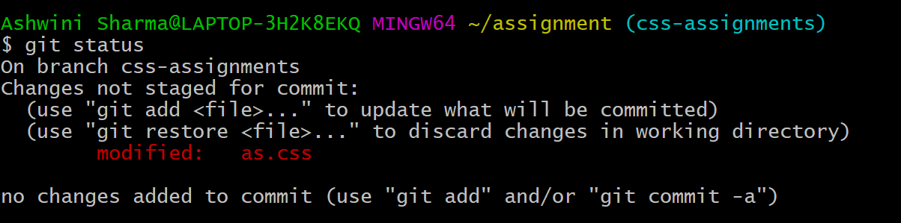

1. Commit those changes.

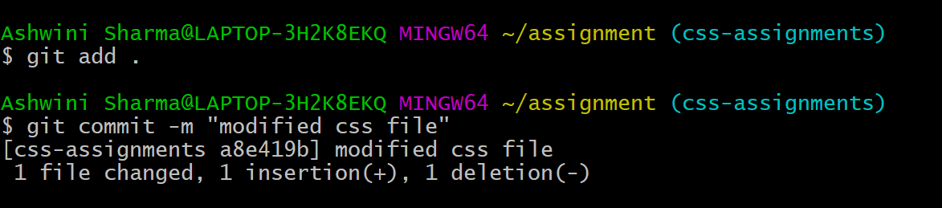

1. Switch to master.

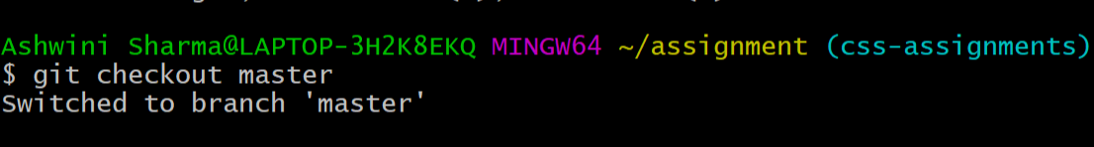

1. Merge ‘css-assignments’ branch into master. Confirm all css assignments are shown in master.

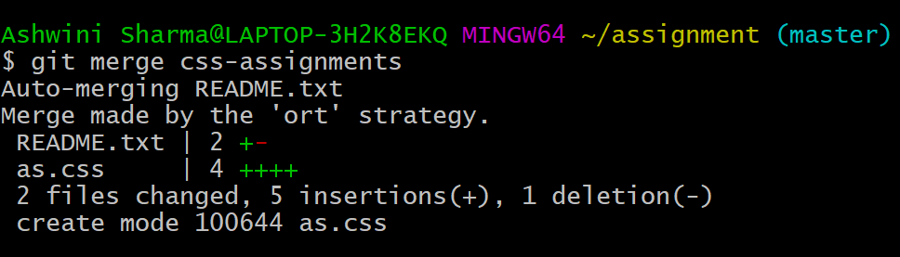

1. Finally delete the ‘css-assignments’ branch.

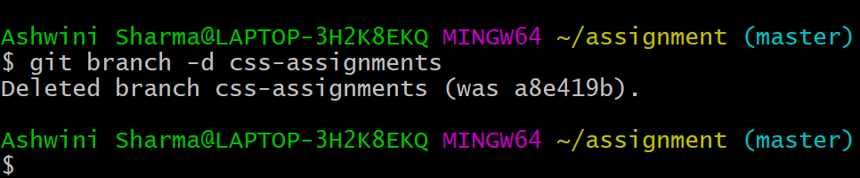

**SECTION-3 - (JavaScript assignments) Steps to follow:**

1. Create a new branch ‘js-assignments’.

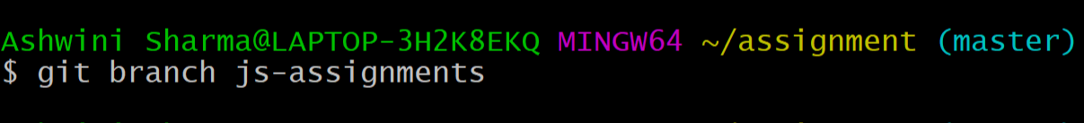

1. Switch to ‘js-assignments’ branch.

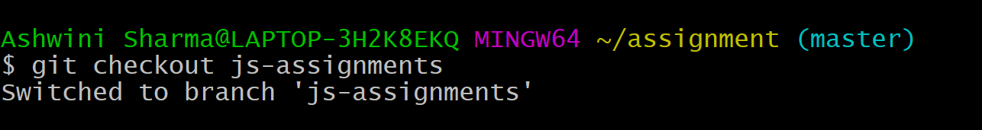

1. Copy all JavaScript assignments inside ‘Assignments’ folder.

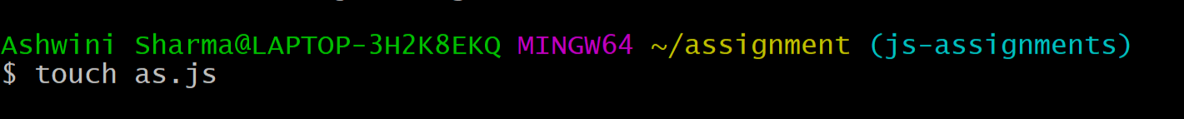

1. Commit JavaScript assignments into ‘js-assignments’ branch.

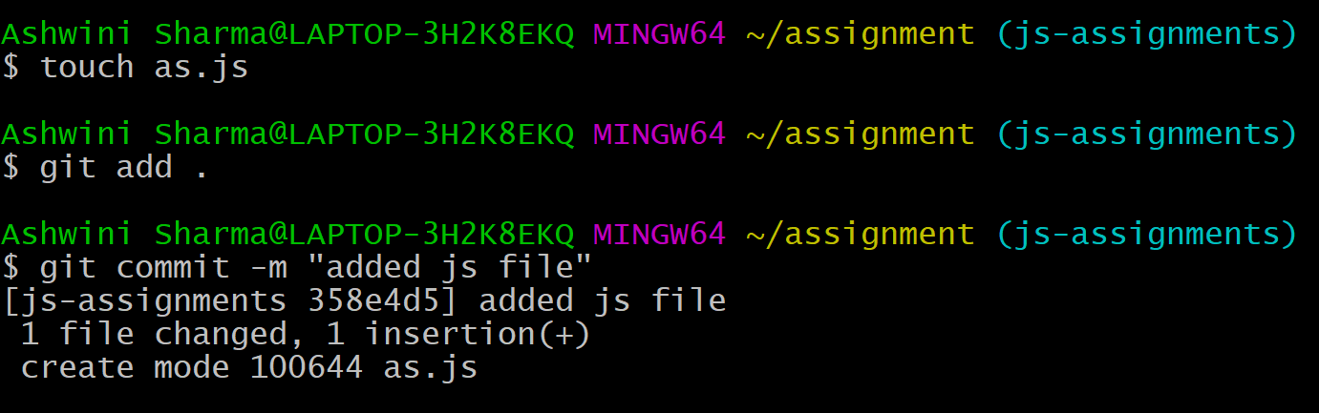

1. Make minor changes into README.txt file on line 1 belonging to ‘js-assignments’ branch.

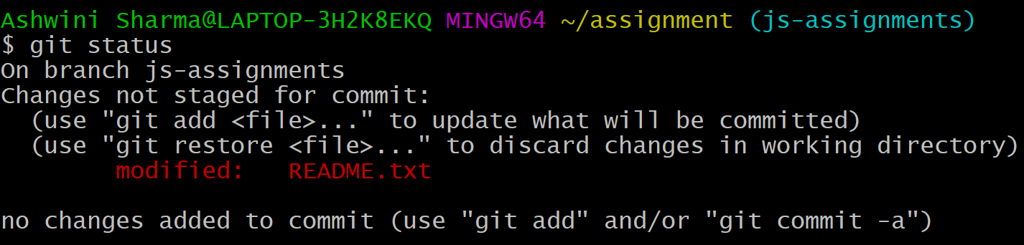

1. Commit those changed files.

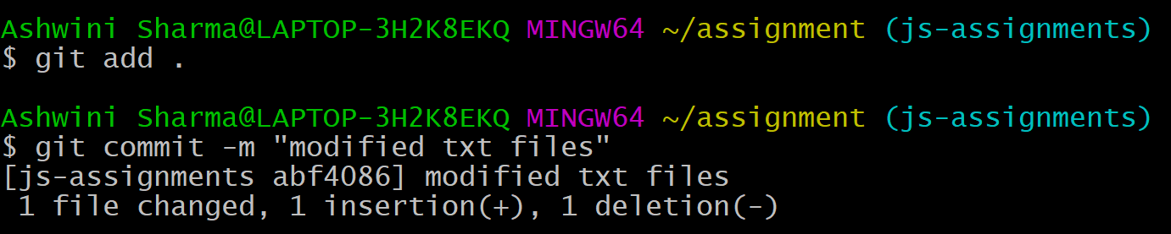

1. Switch to master branch.

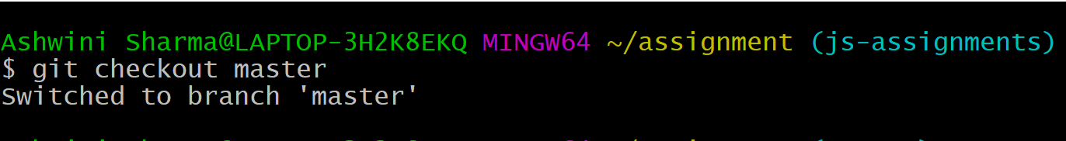

1. Make minor changes into README.txt file on line 1 & commit those changes into master.

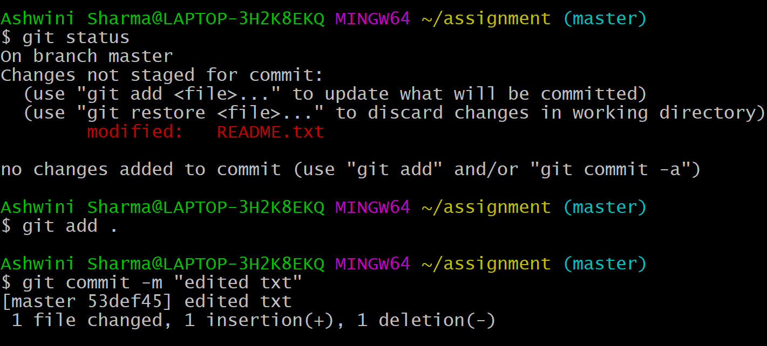

1. Again switch to ‘js-assignments’ branch.

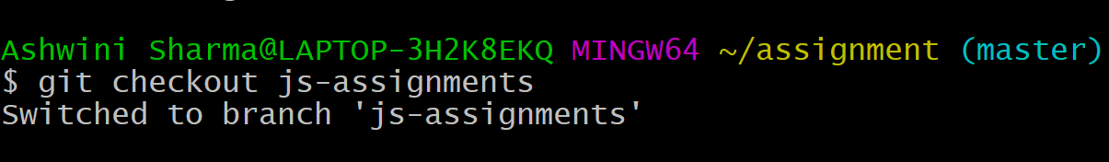

1. Make minor changes into few files belonging to ‘js-assignments’ branch.

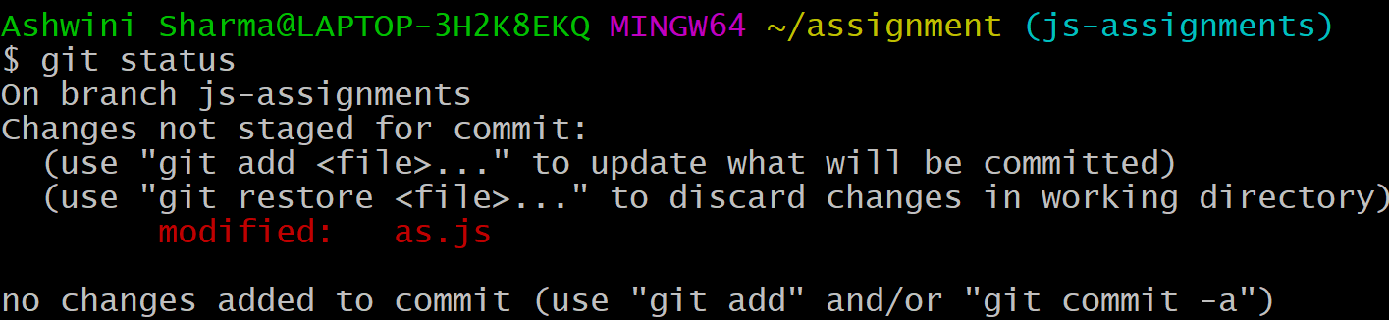

1. Commit those changes.

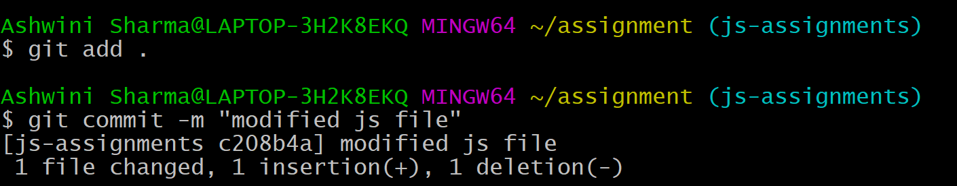

1. Switch to master.

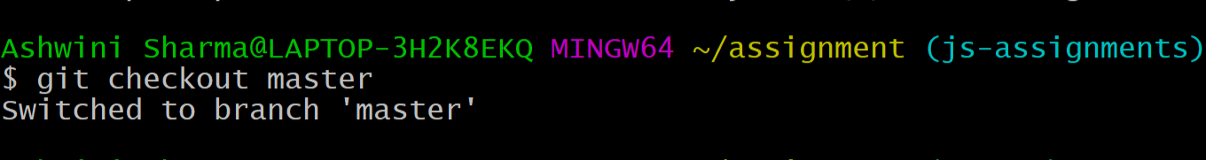

1. Merge ‘js-assignments’ branch into master. Confirm all JavaScript assignments are shown in master.

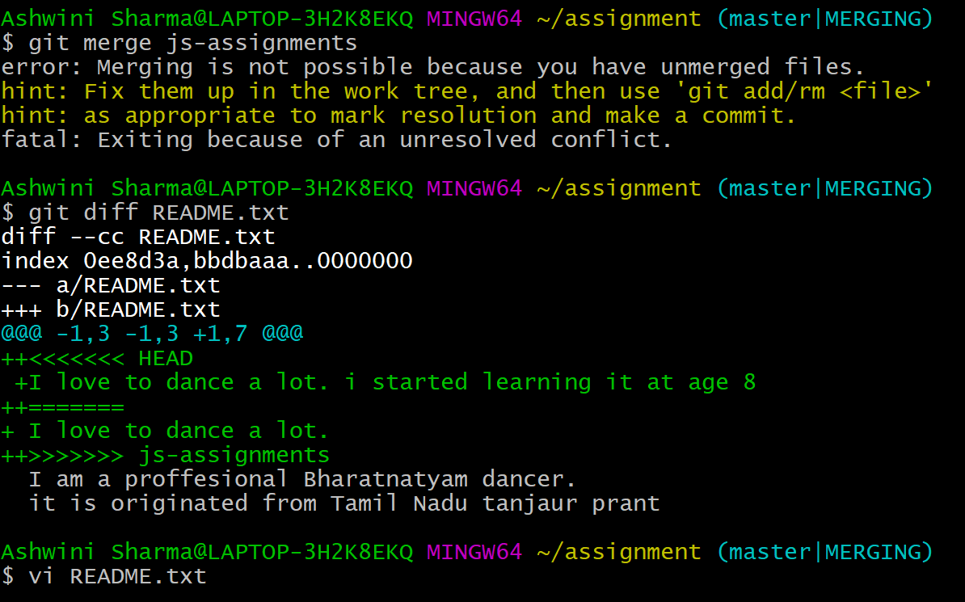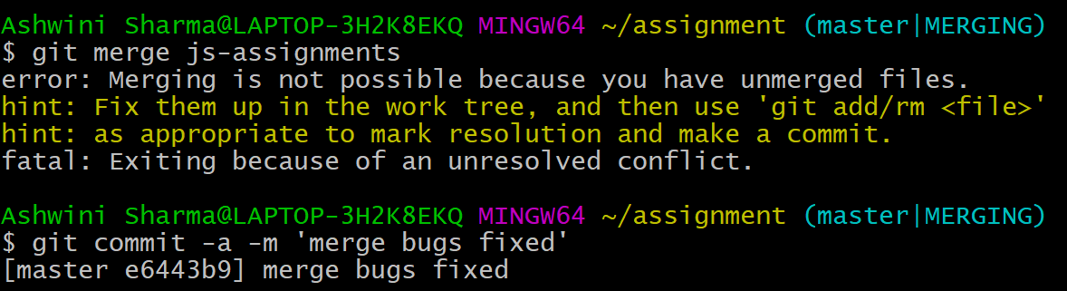

1. Finally delete the ‘js-assignments’ branch.

